PRACTICAL 3:
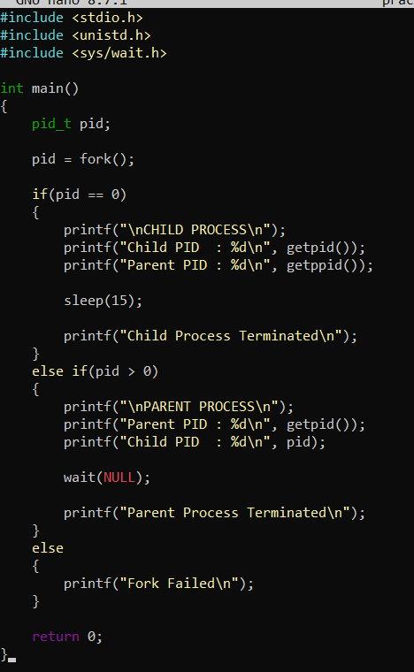
OUTPUT: 